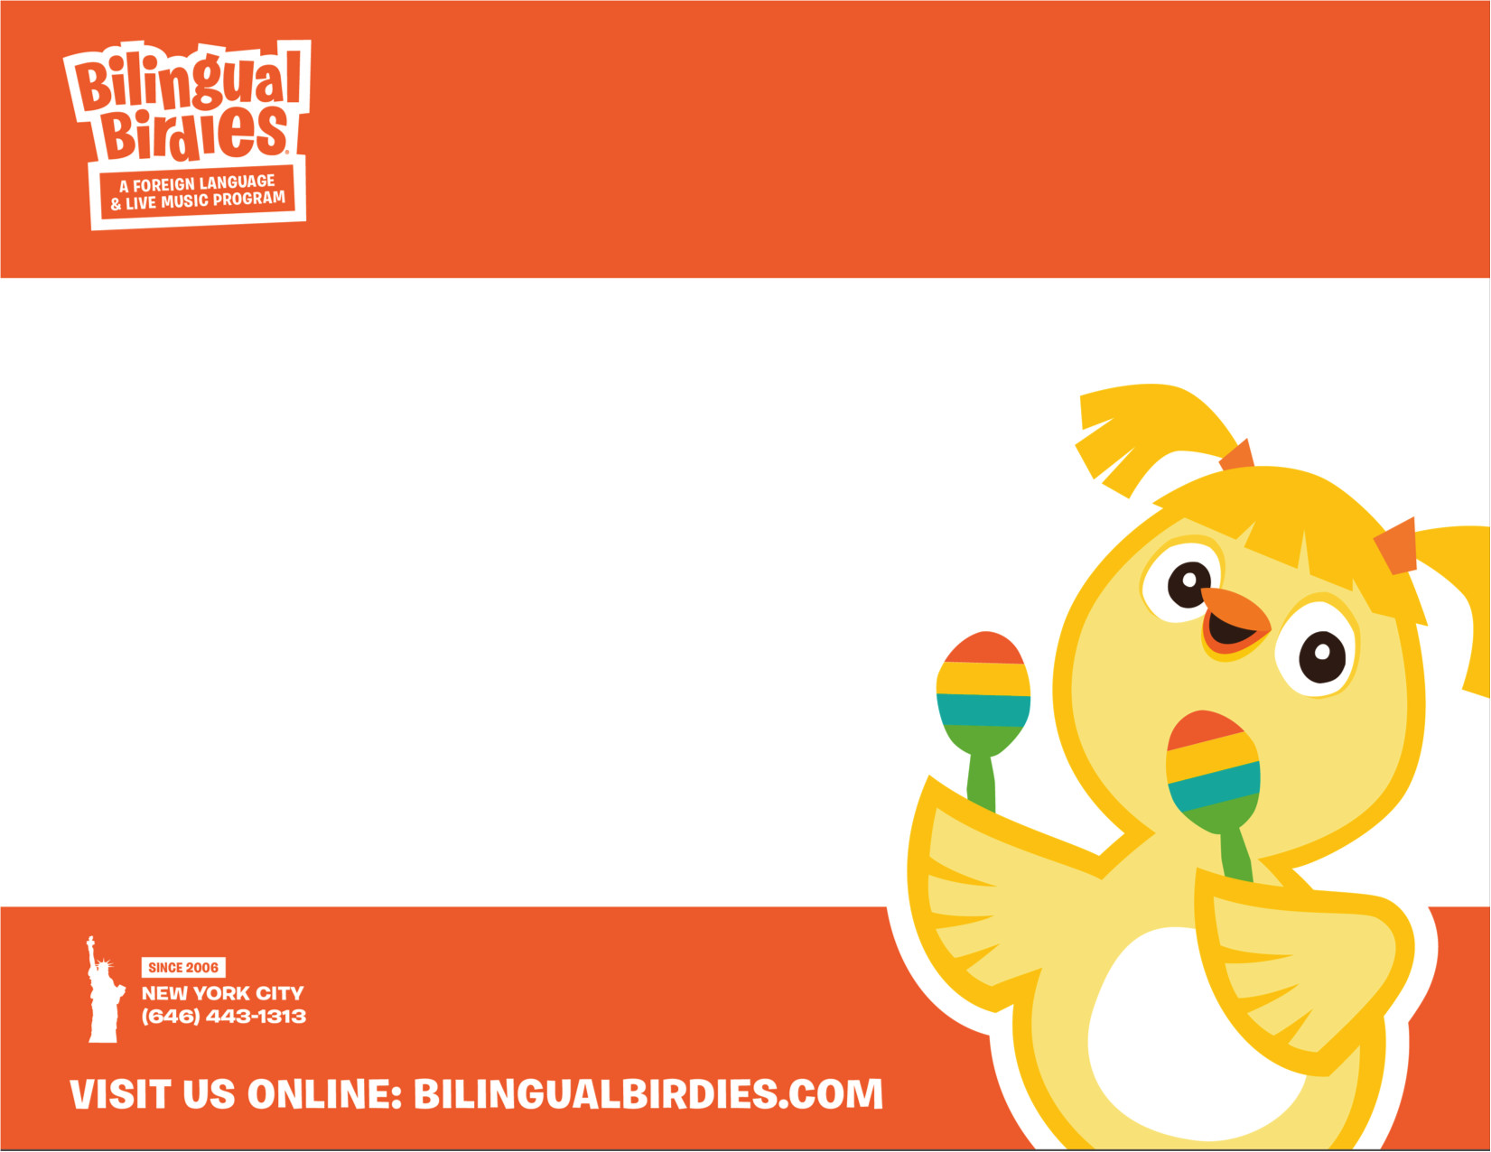

**TEXT TEXT TEXT TEXT**

**TEXT TEXT**

**Bilingual Birdies Concert!**

**BPOS - COBBLE HILL**

Wednesday 06/12

From 10:00 – 10:45am

See what your kids have been

learning in Spanish all year!